**Question 1:**

1. ● Create payload for windows.
2. ● Transfer the payload to the victim's machine.
3. ● Exploit the victim's machine.

**Steps: -**

Create Game.exe in Kali and tried opening In Victim Machine

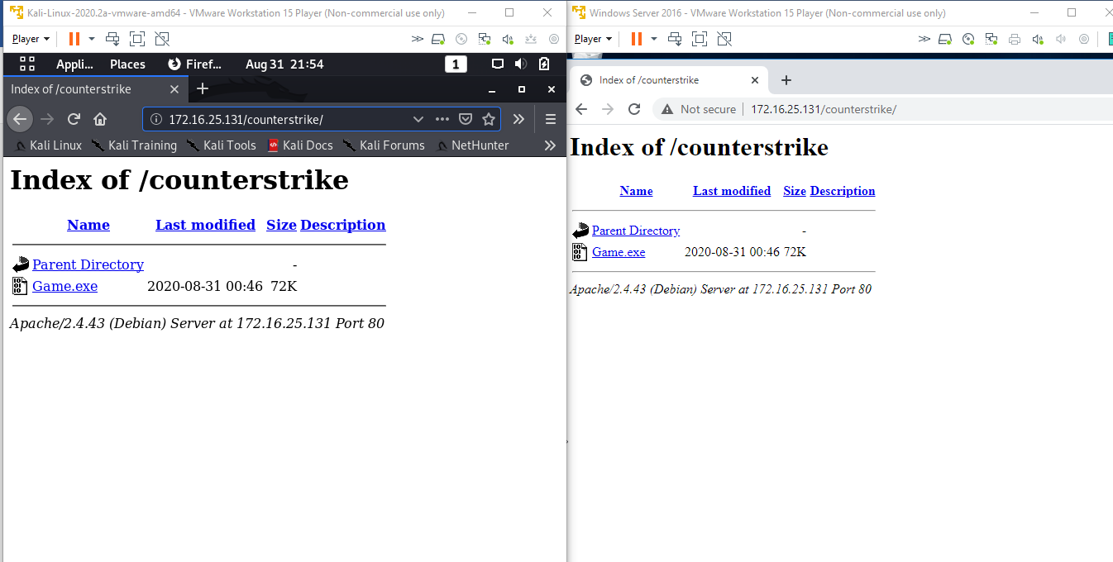

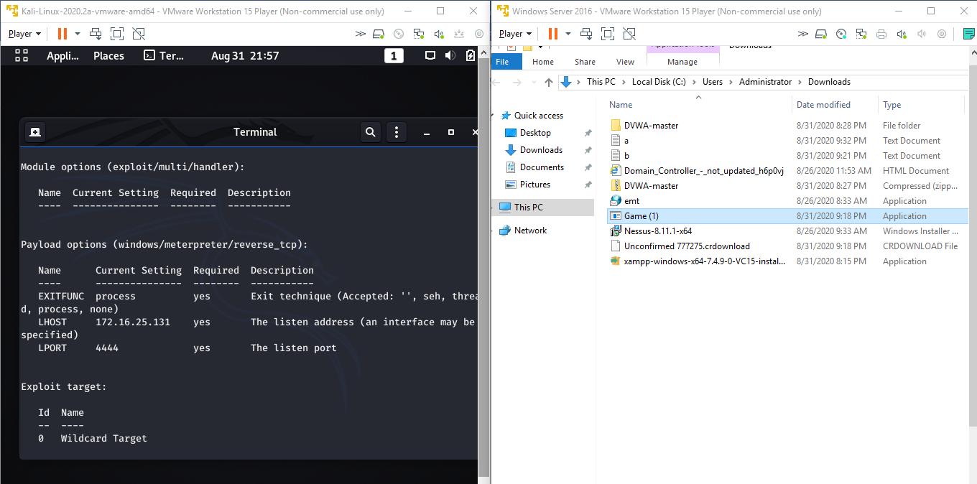

Exploitation Started of the Victim Machine (All details received from the Victim Machine)

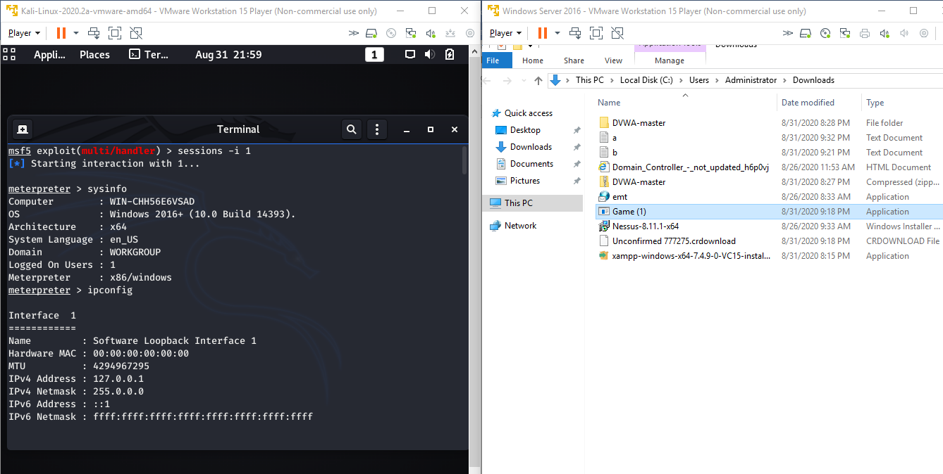

Upload and Download of the a.txt & b.txt in the Victim Machine successfully

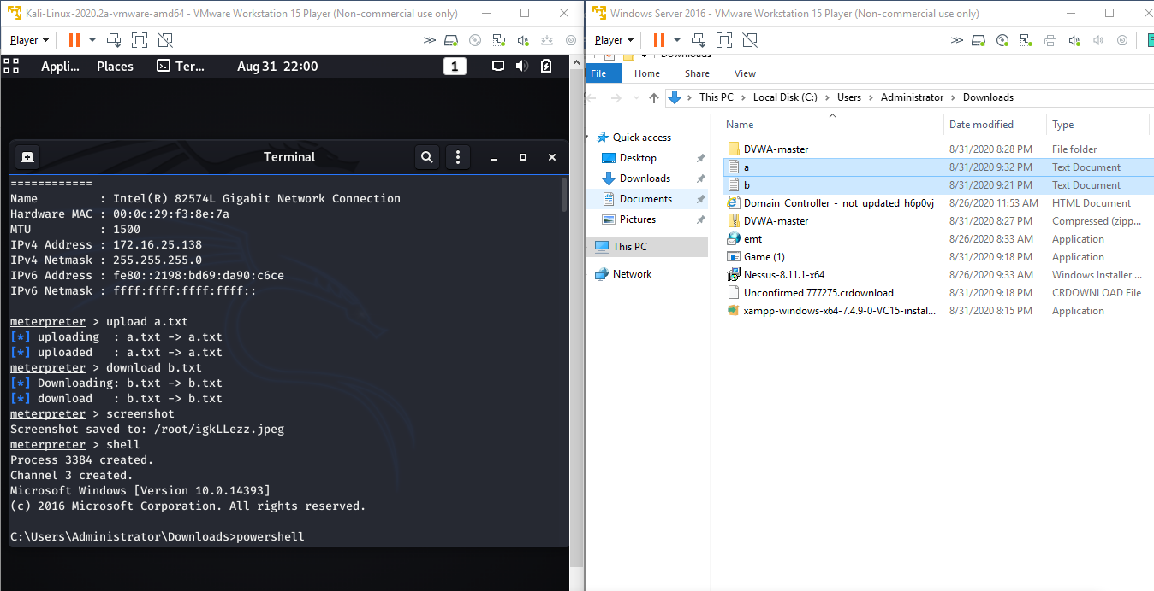

Screenshot taken of the Victim Machine

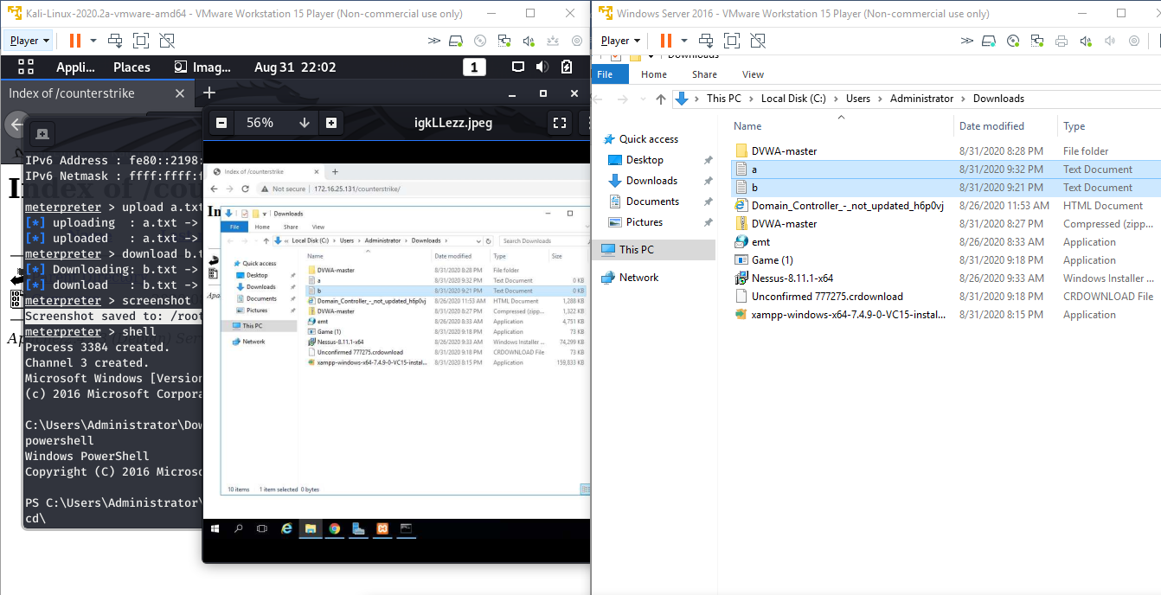

Made the CPU memory a bit high by increasing the load from kali in the Victims Machine

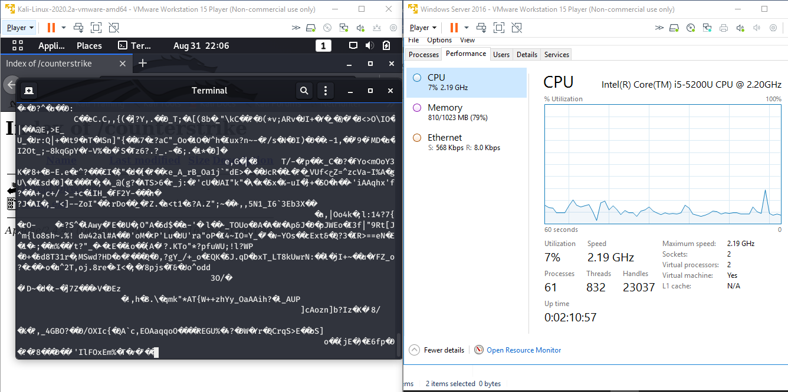

Question 2:

1. ● Create an FTP server
2. ● Access FTP server from windows command prompt
3. ● Do an mitm and username and password of FTP transaction using wireshark and dsniff.

**Steps: -**

Created FTP in Victim and Able to log in in FTP from Pen Tester System

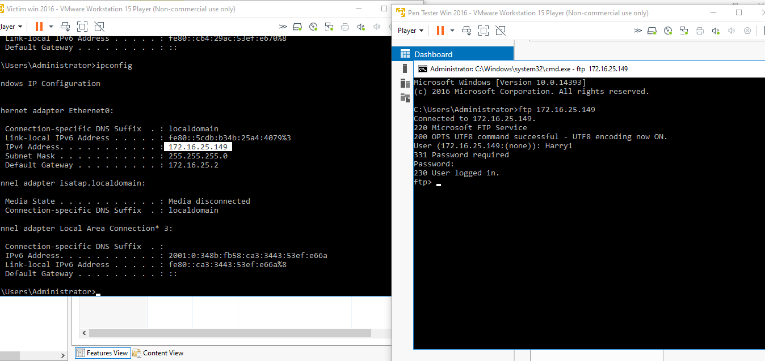

Using dsniff Username & Password of Ftp transaction is displayed below

Username of FTP: - Harry1

Password: - 1234@abcd

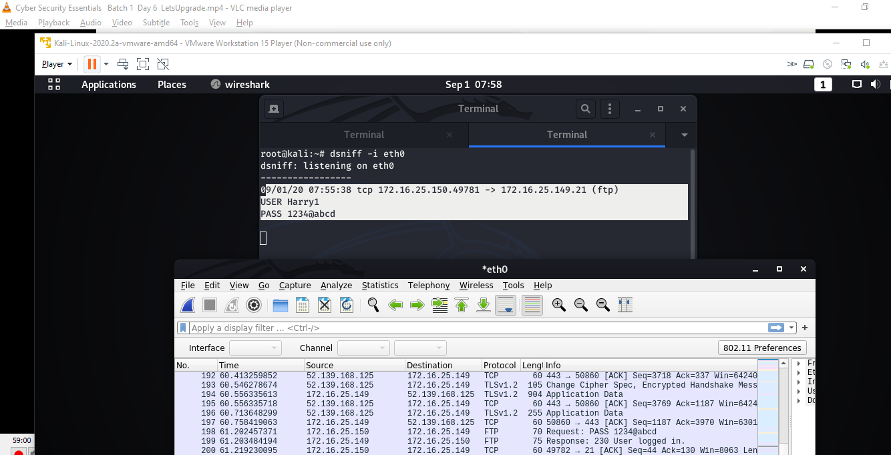

Using Wireshark Username & Password of Ftp transaction is displayed below

Username of FTP: - Harry1

Password: - 1234@abcd

